Photoshop
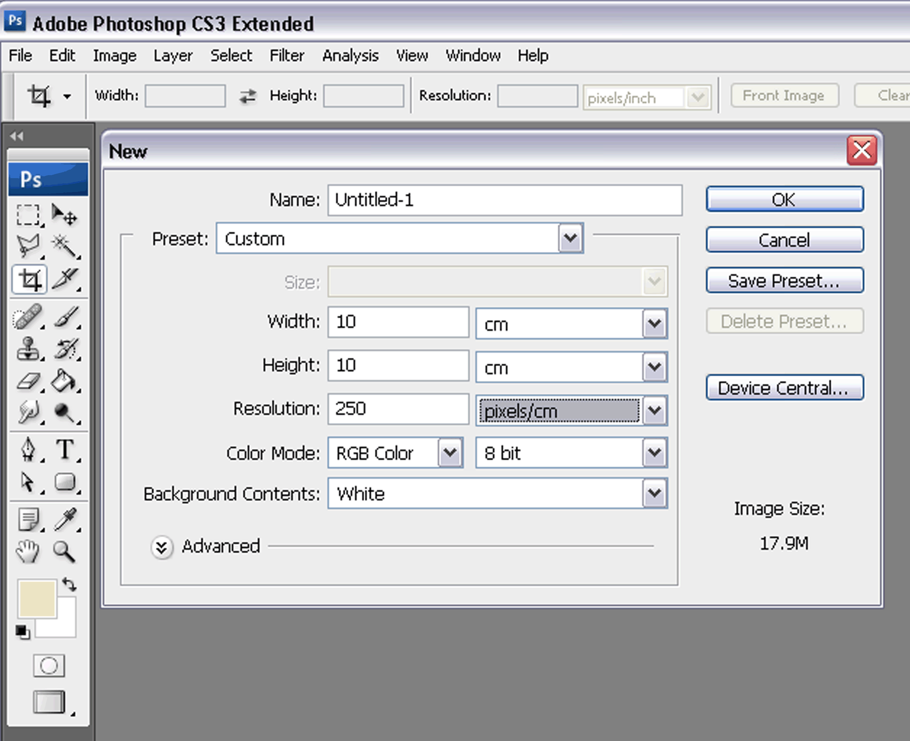
Rectangular Marquee Tool (M)
This tool allows you to select the image. (ctrl + D allows de-selection of the area). There are different shapes in the drop down.
Move Tool (V)
To move objects within the page select the move tool, click and drag.
Polygon Lasso Tool (L)
In the drop down there are different types of lassos to use in selecting parts of images. The Polygon allows you to draw selections in different shapes. Click and drag to draw around an area. To finish either join to the starting point or double-click.
Magic Wand Tool (W)
The Wand allows you to select particular colours within a shape. The tolerance level can be changed as to the amount of selection required.
Crop Tool (C)
The Crop Tool allows you to crop the image by selecting the area and adjusting handles.
Slice Tool (K)
This tool is used for splitting an one image into smaller ones when saving out.
Healing Brush Tool (J)
The Healing tool is used for repairing scratches on images. It can be used like a Brush tool. By holding the [Alt] key, select an area of your image to be copied. Release the [Alt] key and paint over the area to be corrected.
Brush Tool (B)
The Brush tool can be used to paint on your image.
Clone Stamp Tool (S)
The Clone tool is similar to the Healing Brush Tool. The difference with the Clone tool is that it doesn’t blend at the end. It is a direct copy of the selected area.
History Brush Tool (H)
The History brush tool paints with the history from the original state of your image. In the History Palette select the history state. The History Brush tool paints with the information from whatever History state is selected.
Eraser Tool (E)
The Eraser tool deletes information wherever you click and drag it. If you’re on a Layer, it will erase the information transparent. If you are on the background layer, it erases with whatever secondary color you have selected.
Gradient Tool (G)
The Gradient tool allows for the blending of the foreground and background colours when you click and drag it.
Blur Tool (R)
The Blur tool alters the image to create a blur effect.
Dodge Tool (O)
The Dodge tool lightens selected areas.
Path Selection Tool (A)
The Path Selection Tool together with the Pen tool, in creating paths.
Horizontal Type Tool (T)
The Horizontal Type Text allows text to be typed in an area. By placing the cursor and clicking, or click and drag to make a bounding box, you can add text to your document.
Pen Tool (P)
The Pen tool is used to create paths. This is another way of selecting an area. By dragging and clicking an anchor point is added, allowing you to bend and shape the path for accurate selections.
Rectangle Tool (U)
The tool draws a shape in the form of a rectangle and fills it with whatever foreground colour you have selected.
Notes Tool (N)
The Notes tool allows for small note boxes to be added to your image for further reference.
Eyedropper Tool (I)
The Eyedropper tool works by changing your foreground color to whatever color you click on. Holding the [Alt] key will change your background color.
Hand Tool (T)
The Hand tool is for moving your entire image within a window.
Zoom Tool (Z)
The Zoom tool allows for zooming into your image.
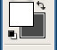
These are your color boxes. Foreground (in the front) and Background (in the back). Click on either one to bring up the color select dialog box.

