Open Mahara
- Select My Files
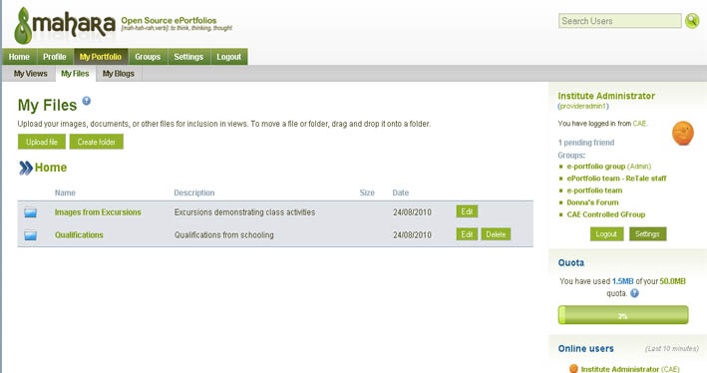
- Create folders to contain your documents
- Add files to the folders
My Views
- Select My Views
- Create View icon
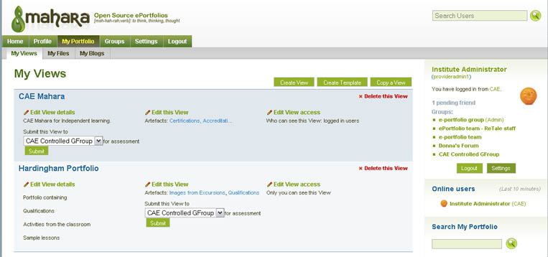

Creating the Layout
- Select each option to create the layout.
