Making a profile in Mahara.
Information that is entered into your profile is private from everyone except the Administrator.
Editing your profile
- Select the Profile button on the main menu.

- Mahara will open the Profile submenu. The Edit Profile tab allows changes to be made to your profile.

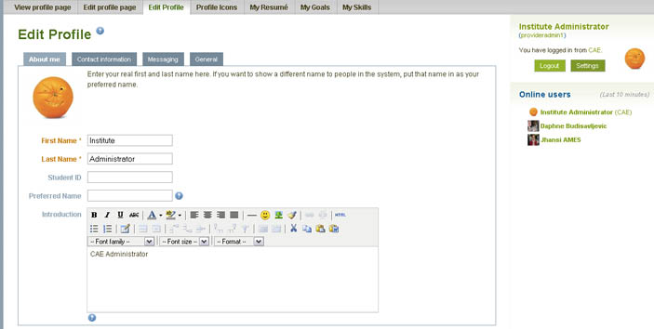

- When you make changes to your Profile page click the Save Profile button at the bottom of the page.

- Contact Information allows you to add contact details. Do not disclose personal information. You don't have to complete all the fields if you don't want to.

- In Messaging you can meet people in live text, audio, and video conferences. Details can be displayed to each other in their profile page and other web pages.

- The tab General allows you to enter your Occupation and Industry.

Profile icons
Profile icons are used so that you can be identified by other members. Mahara allows you to upload up to five different profile icons.
- Click the Profile submenu button called Profile Icons.
- Browse to find the image icon you want to upload. Add an Image Title for your profile icon before you click the upload button.
- You can upload up to five profile icons and you can delete any icon. You will need to choose one of your icons as your default profile icon.
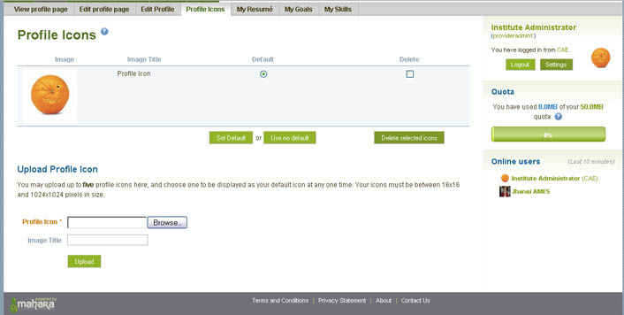

Edit Profile
To edit your Profile page so that specific items are displayed select Edit Profile page.
- Drag the icons into the space that you want displayed on your profile page.

